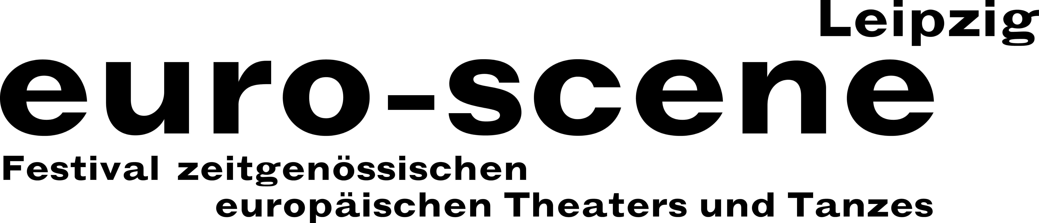
PRESS RELEASE – 02.07.2020

For the 30th time: Vision Europe – an open door to the stranger

Reunions and new acquaintances at euro-scene Leipzig

euro-scene Leipzig will be celebrating its 30th anniversary from 03. – 08. November 2020. The festival of contemporary European theatre and dance will be showing 12 guest performances from 7 countries in 22 performances at 7 venues. This year, the spectrum is especially wide and offers a range of spoken theatre and dance, music and puppet theatre as well as a children’s piece. As in past years, the festival enjoys the patronage of Burkhard Jung, the mayor of the City of Leipzig.

This year’s motto, “Alles nicht wahr” (“It simply ain’t so”), makes reference to the contradictions between assertions, lies and truth that hardly seem resolvable in an age of “fake news” in the daily chaos of messages. However, a steadfast longing for trust and honesty remains.

We are assuming that our festival will be able to take place as planned, of course, while abiding by all necessary hygienic measures should such regulations still be in force at the beginning of November.

euro-scene Leipzig was founded in 1991 and belongs to Leipzig’s cultural highlights and is one of the most important festivals of its kind in Europe. With its motto from the very beginning “Vision Europa – dem Fremden eine Tür” (“Vision Europe – an open door to the stranger”) it has proved itself to be far ahead of its time and is steadily referring to current happenings until today. Several artists, who have especially shaped the festival, return to Leipzig this year once again. Among them is Nikolaus Habjan, puppet builder and puppeteer, director and performer from Vienna who will – together with Musicbanda Franui – open euro-scene Leipzig with the piece “Alles nicht wahr” (“It simply ain’t so”) based on songs by Georg Kreisler as a German première at the Gewandhaus zu Leipzig / Mendelssohn-Saal.

Nikolaus Habjan will also share the stage for the first time with the famous puppeteer Neville Tranter, from whom he learned his puppet craft, in “The hills are alive”, a guest performance from the Schauspielhaus Graz. In addition, the audience will once again be able to experience his shocking piece “F. Zawrel – erbbiologisch und sozial minderwertig” (“F. Zawrel – genetically and socially inferior”) as an outstanding festival contribution in Leipzig.

Opulent dance is represented by two pieces of “classical modernity”: “Sideways rain” by Guilherme Botelho and his Compagnie Alias from Geneva as well as “May B” by Maguy Marin from Lyon belong to the best dance pieces in recent decades. After guest performances in 2011 and 1999 it succeeded inviting them once again.

Compagnie Berlin from Antwerp will be first-time guests with their piece “True copy” about the art forger Geert Jan Jansen as well as Rita Góbi – together with Ferenc Fehér – in an evening with Dance from Budapest. Other guest performances come from Toulouse, Lausanne, Vordingborg and Berlin.

This year the programme selection is in the hands of Ann-Elisabeth Wolff, Festival Director since 1994, for the last time, before a new artistic direction will start in 2021. euro-scene Leipzig is financed by the City of Leipzig and the Cultural Foundation of the Free State of Saxony as well as the consulates of the guest performance countries. The cultural partners are ARTE and MDR Kultur.

euro-scene Leipzig / Ann-Elisabeth Wolff, Festival Director / Gottschedstr. 16, 04109 Leipzig
Tel. +49-(0)341-980 02 84 / info@euro-scene.de / www.euro-scene.de

