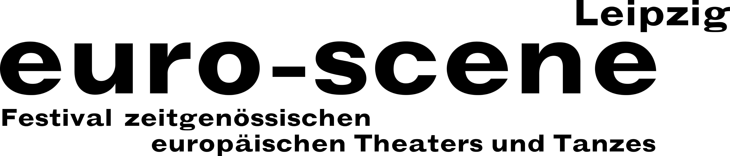

PRESS RELEASE – 23.09.2020

“Alles nicht wahr” (“It simply ain’t so”)
Theatre and dance from Europe on Leipzig’s stages

The festival euro-scene Leipzig will celebrate its 30th anniversary in November.

euro-scene Leipzig will celebrate its 30th anniversary from 03. – 08. November 2020. The festival of contemporary European theatre and dance will show 12 guest performances from 7 countries in 22 presentations and 7 venues. The spectrum ranges from spoken theatre and dance, music and puppet theatre to a children’s piece. The festival enjoys the patronage of Burkhard Jung, the mayor of the City of Leipzig.

In close communication with the City of Leipzig’s health authorities and in a constant exchange about Covid-19 with the venues, the hygiene concepts will be adjusted to their regulations and renewed regularly. At present, there is no concern that the festival anniversary will not occur according to plan – as long as there is no general ban of events in the City of Leipzig. However, due to social distancing rules, there will be a significantly lower audience capacity.

Under the motto “Alles nicht wahr” (“It simply ain’t so”), euro-scene Leipzig will primarily show guest performances this year from artists who are close to the festival. Among them is the puppet magician Nikolaus Habjan from Vienna, a director, reciter and singer who will open the festival with the Musicbanda Franui and the music theatre “Alles nicht wahr” based on songs by Georg Kreisler as a German première at the Gewandhaus zu Leipzig / Mendelssohn-Saal. For the first time, he is also sharing the stage with his former teacher, the world famous puppeteer Neville Tranter, in “The hills are alive”.

Festival Director Ann-Elisabeth Wolff explains a focus of the programme: “In the 30 years of the festival, we have shown pieces that belong to the best of an entire era in terms of their innovation and quality. We succeeded in bringing five of these unusual productions to Leipzig once again. Among them are the two thrilling dance pieces “Sideways rain” by Guilherme Botelho and his Compagnie Alias from Geneva as well as “May B” by Maguy Marin from Lyon.” And she continues: “The great solo “F. Zawrel – erbiologisch und sozial minderwertig” (“F. Zawrel – genetically and socially inferior”) by and with Nikolaus Habjan is, as a result of its brilliant approach to language, political commitment and emotions, a theatre experience that can hardly be matched. It will, after its guest performance in 2016, be shown once again.” A strong contrast: the magical comedy “Brevet” (“The letter”) with Paolo Nani from Denmark; it has been performed 1,650 times in 43 countries since 1992.

After 30 years of festival work, Ann-Elisabeth Wolff will be stepping down as Festival Director and place the directorship into the hands of her successor, Christian Watty. The festival is financed by the Cultural Administration of the City of Leipzig and the Cultural Foundation of the Free State of Saxony. The total budget in 2020 is € 570,000.00 including the support from guest performance countries and planned ticket revenues.

euro-scene Leipzig / Festival Office: Gottschedstr. 16, 04109 Leipzig, Germany
Tel. +49-(0)341-980 02 84 / info@euro-scene.de / www.euro-scene.de

