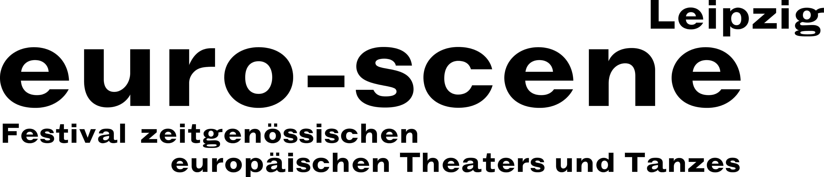

PRESS RELEASE – 30.10.2020

euro-scene Leipzig theatre and dance festival cancelled

Theatres are closing one day before the planned festival opening

The 30th anniversary of euro-scene Leipzig theatre and dance festival, which was planned for the 03. – 08. November unfortunately must be cancelled. The reason for this step is the federal government’s decision to prohibit all public events due to the rapidly increasing Covid-19 infection rate starting 02. November. This date is one day before the planned festival opening that was originally supposed to take place with Nikolaus Habjan and the Musicbanda Franui from Vienna and the piece “Alles nicht wahr” (“It simply ain’t so”) at the Gewandhaus zu Leipzig / Mendelssohn-Saal on 03. November.

euro-scene Leipzig waited until now to cancel and made every effort to realize the festival in a constant coordination with the health authorities and venues. It was going to be Ann-Elisabeth Wolff’s last programme; after thirty years of festival work, she will be placing the directorship in new hands. In total, 87 artists from 7 countries were going to arrive in order to present 12 guest performances in 22 showings and 7 venues. After intense preparations, there were no further obstacles to realizing the festival.

“That the federal government’s decision to prohibit all public events will take effect one day before the planned festival opening is very tragic for both the companies and the audience,” Ann-Elisabeth Wolff explains. Almost all performances are sold out. All admission costs for tickets that have already been purchased will be reimbursed. Moving the entire anniversary festival in its totality will not be possible due to the new festival directorship in 2021. To what extent programme positions will be able to be included in future festivals is something that will be looked into.

euro-scene Leipzig / Ann-Elisabeth Wolff, Festival Director
Tel. +49-(0)341-980 02 84 / info@euro-scene.de / www.euro-scene.de

