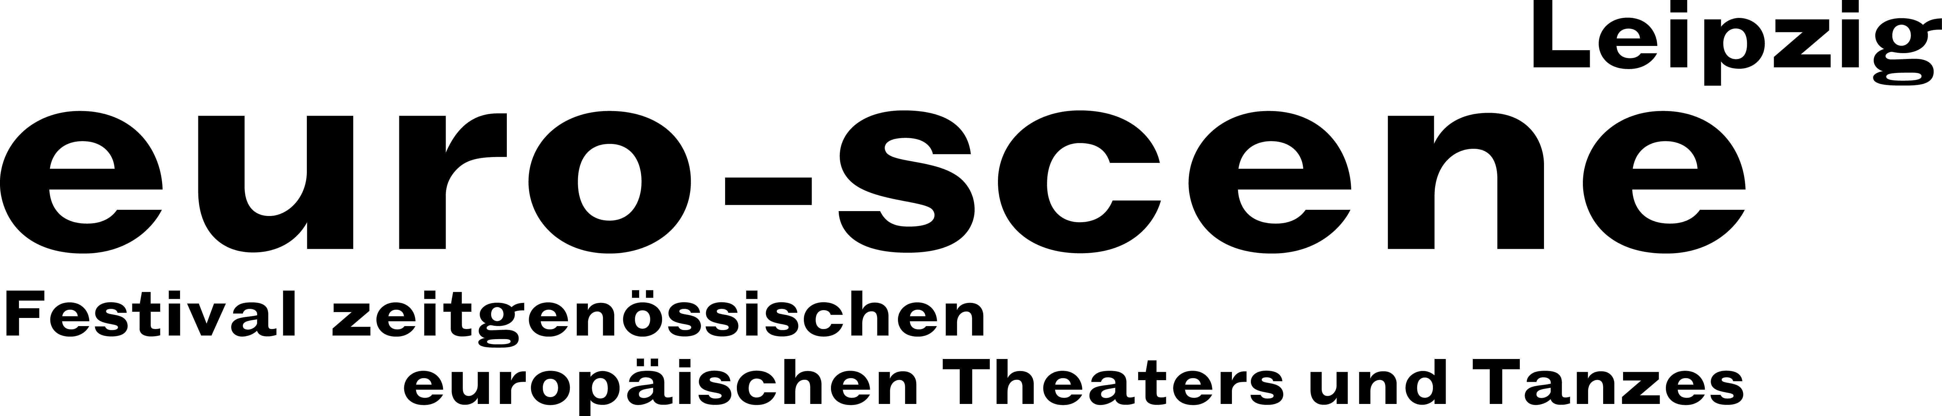
PRESS RELEASE – 26.09.2018

Mozart meets African folklore, hip-hop meets jazz and opera is whistled

The 28th euro-scene Leipzig festival is devoted to music in theatre and dance and is affected by financial cuts

euro-scene Leipzig will take place for the 28th time from 06. – 11. November 2018. The festival for contemporary European theatre and dance will show 11 guest performances from 7 countries in 20 presentations at 8 venues; among them are 5 German premières. The spectrum includes dance and spoken theatre, music theatre, performances and a children’s piece. The festival’s patron is Burkhard Jung, the mayor of the City of Leipzig. The programme selection lies in the hands of the festival director, Ann-Elisabeth Wolff, in cooperation with the Artistic Advisory Council.

This year’s festival motto is “Bühnen – Klang – Welten” (“Stage – Sound – Worlds“). The programme is devoted to music in theatre and dance, whereby numerous forms of implementing music in scenic stage forms will play a role, for example in a relationship to live music, sound, noise, text and silence.

The famous choreographer and director Alain Platel from Belgium will open this year’s
euro-scene Leipzig at the Schauspielhaus with “Requiem pour L.“ (“Requiem for L.”). The scenic concert combines Wolfgang Amadeus Mozart’s Requiem with African music and is devoted to the subject of death in a variety of cultures. Another classical work can be heard as well: Ludwig van Beethoven’s Symphony No. 9. In the performance “Deveta“ (“The ninth“), Bojan Jablanovec from Ljubljana and his Compagnie Via Negativa pose questions about power and the instrumentalization of music.

The well-known puppet builder, puppeteer, director and performer Nikolaus Habjan from Vienna is – after the enthusiastic response to his 2016 showcase – Leipzig’s guest once again: He directed the piece “Böhm“ at the Schauspielhaus Graz; it is devoted to Karl Böhm, one of the most important directors of the 20th century and also a willing pawn of National Socialism. Nikolaus Habjan performs the great solo together with numerous puppets. In addition, he will also show his humorous artistic whistling concert “Ich pfeife auf die Oper“ (double meaning in German: “I whistle an opera” and “To hell with the opera”) with arias from operas and operettas. Here, he revives the baroque art of artistic whistling.

Dance is well represented: Nono Battesti, Brussels, mixes captivating dance duets with jazz songs; Gianfranco Celestino & Annalisa Derossi, Luxembourg, present themselves as dancers as well as pianists; and Ferenc Fehér from Budapest is giving a guest performance with a suggestive dance piece.

Spoken theatre comes from London: The Compagnie ERRATICA with its piece “Remnants“ by
Patrick Eakin Young enters into historic abysses accompanied by a-cappella-music. And
“Die Schachnovelle“ (“The royal game“) (based on the famous novella by Stefan Zweig) will be shown in a scenic version by Geirun Tino with the Pygmalion Theater Wien.

Two guest performances from France round off the festival programme: The magical children’s piece “Une histoire de la musique“ (“A history of music“) by the Compagnie zOrozora from Grenoble leads us through the centuries with three musicians/performers. And at the final night the choreographer Pierre Rigal from Toulouse will show his dance piece “Scandale“ (“Trip hazards“) with up-tempo hip-hop-elements.

euro-scene Leipzig is financed by its strongest partner, the City of Leipzig. The Cultural Foundation of the Free State of Saxony reduced its support this year. Given the high level of the festival’s recognition within Germany and abroad as well as its constant high audience capacity rates (99,2 % last year), this is an inexplicable occurrence. As a result, two guest performances had to be cancelled and the fringe programme shortened. We hope that this remains a one-time occurrence.

Ann-Elisabeth Wolff
Festival Director

Contact: euro-scene Leipzig / Tel. +49-(0)341-980 02 84 / info@euro-scene.de / www.euro-scene.de

