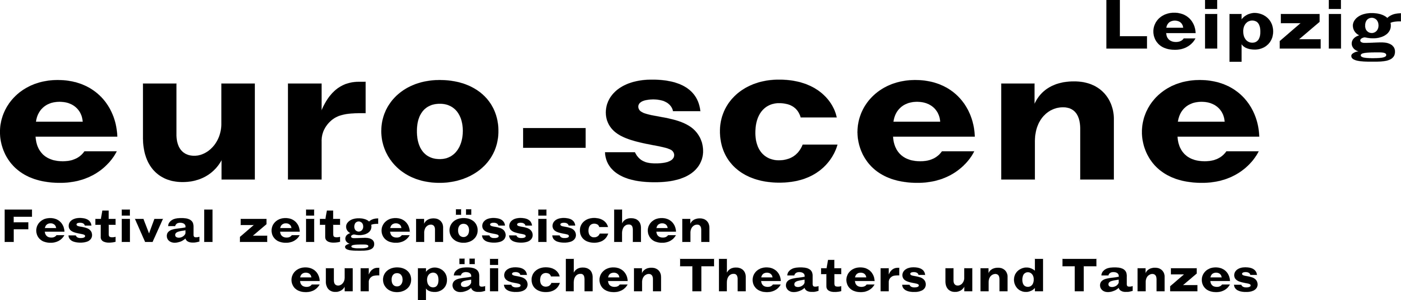
PRESS RELEASE – 04.11.2019

euro-scene Leipzig is starting into “Parallelwelten” (“Parallel worlds”) tomorrow

Theatre and dance from Europe with 10 guest performances on 7 stages in Leipzig

On this Tuesday, the theatre and dance festival euro-scene Leipzig will open at the Schauspielhaus with the piece “Am Königsweg” (“On the royal road”) by the Austrian Nobel prize winner Elfriede Jelinek. Nikolaus Habjan, well-known puppet builder and director from Vienna, staged the highly controversial text with 6 actors and numerous puppets at the Landestheater Niederösterreich, St. Pölten, as an Austrian première. The mix of elements from a Greek tragedy, Shakespeare’s history plays and the Muppet Show is breathtaking.

euro-scene Leipzig is taking place from 05. – 10. November 2019 for the 29th time. It will feature 10 guest performances in approximately 22 performances at 7 venues, among them 5 German premieres. Under the motto “Parallelwelten” the festival features dance and spoken theatre, performances and a piece for children. Leipzig’s Mayor, Burkhard Jung, is serving as the festival’s patron. The festival director, Ann-Elisabeth Wolff, is responsible for selecting the programme in cooperation with the Artistic Advisory Council.

The spectrum ranges from the dance piece “Das Lackballett” (“The Laquer ballet”) (1941), based on Oskar Schlemmer, by the Theater der Klänge, Dusseldorf, on the occasion of the Bauhaus centennial to the original mono-opera “Diary of a madman”, based on Nikolai Gogol, by Marjan Nečak from North Macedonia. The performance “VR_I” by the Swiss choreographer Gilles Jobin blends dance with virtual reality à 20 minutes for 5 viewers each. Two magnificent dance solos are included with Cristiana Morganti, long-term soloist with Pina Bausch, from Rome and Jan Martens from Antwerp. As a highlight, the Ballet Preljocaj from Aix-en-Provence dances three pieces by Angelin Preljocaj, one of the most important choreographers in France, as a splendid final night of the festival. The popular competition “Das beste deutsche Tanzsolo” (“Best German dance solo”) in the spirit of Alain Platel from Ghent is held for the 14th time.

euro-scene Leipzig is financed by the City of Leipzig and the Cultural Foundation of the Free State of Saxony as well as numerous representatives of the guest performance countries and other partners. Cultural partner of the festival is MDR Kultur.

Ann-Elisabeth Wolff
festival director

Information and contact: euro-scene Leipzig, Gottschedstraße 16, 04109 Leipzig,
tel. +49-(0)341-980 02 84 / info@euro-scene.de / www.euro-scene.de

