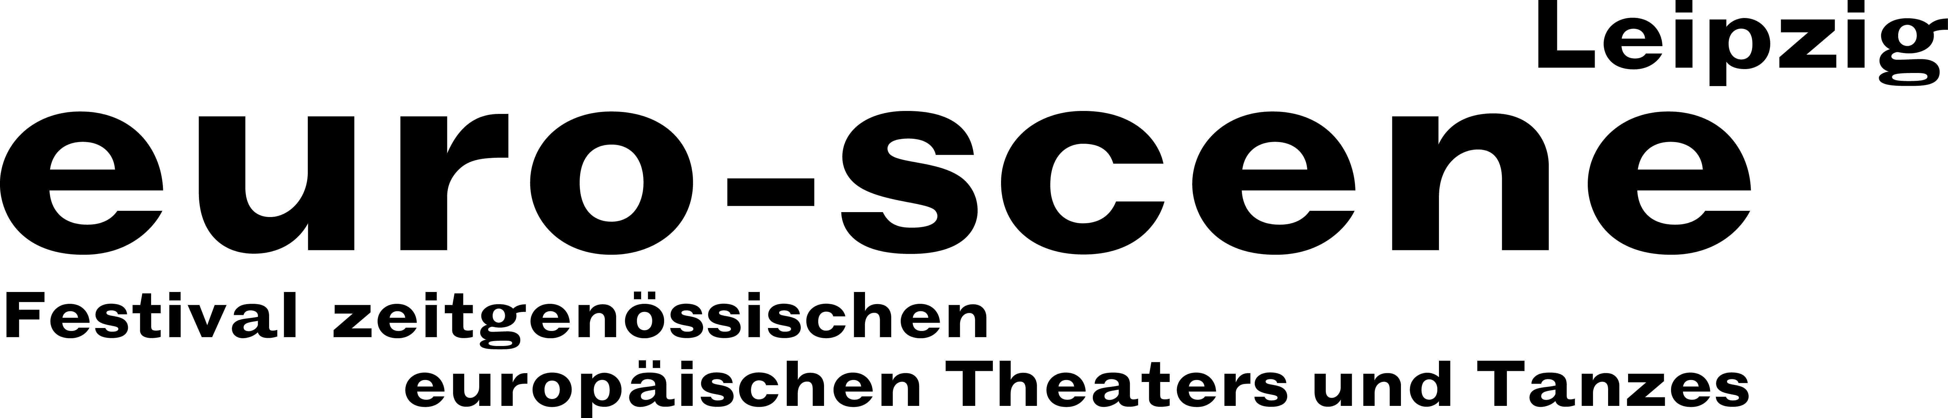
PRESS RELEASE – 10.11.2019

The theatre and dance festival euro-scene Leipzig concludes successfully today

Tonight euro-scene Leipzig, under the motto “Parallelwelten” (“Parallel worlds”), is coming to a close with three dance pieces by Angelin Preljocaj, one of France’s best known choreographers. In a Soirée Preljocaj the Ballet Preljocaj from Aix-en-Provence brings to life the parallel worlds of the choreographer with echoes of the classical ballet all the way to a highly modern dance language.

euro-scene Leipzig took place for the 29th time from 05. – 10. November 2019. With 94.4 % the festival for contemporary European theatre and dance achieved a high percentage of seats sold, same as it did in the previous years. 5.400 spectators saw 9 guest performances from 8 countries in approximately 22 performances at 7 venues, including 5 German premières.

Among the highlights of the broad theatrical spectrum was “Das Lackballett” (“The laquer ballet”), based on Oskar Schlemmer, newly interpreted by J. U. Lensing with the Theater der Klänge, Dusseldorf, on the occasion of the Bauhaus centennial. The two soli “Jessica and me” by Cristiana Morganti from Rome, long-standing soloist at Pina Bausch’s Tanztheater, and “lostmovements” by Jan Martens from Antwerp showed parallel worlds between inner life and society. The mono-opera “Diary of a madman” based on Nikolai Gogol by Marjan Nečak from North Macedonia enthralled with its experimental style of performance.

The piece “Am Königsweg” (“On the royal road”) by Elfriede Jelinek opened the festival with the Landestheater Niederösterreich, St. Pölten. Nikolaus Habjan, well-known puppeteer and director from Vienna, staged the monumental text as a play with puppets as a topical and controversial political satire. And the Swiss choreographer Gilles Jobin pursued parallel worlds of dance and virtual reality technology for the first time in his performance “VR_I”. Furthermore, the popular competition “Das beste deutsche Tanzsolo” (“Best German dance solo”) took place for the 14th time.

euro-scene Leipzig is financed by the City of Leipzig and the Cultural Foundation of the Free State of Saxony as well as numerous foundations and cultural institutions.

Next year euro-scene Leipzig celebrates its 30th anniversary from 03. – 08. November 2020.

Ann-Elisabeth Wolff
Festival Director

Information and contact: euro-scene Leipzig, Gottschedstraße 16, 04109 Leipzig,
tel. +49-(0)341-980 02 84 / info@euro-scene.de / www.euro-scene.de

