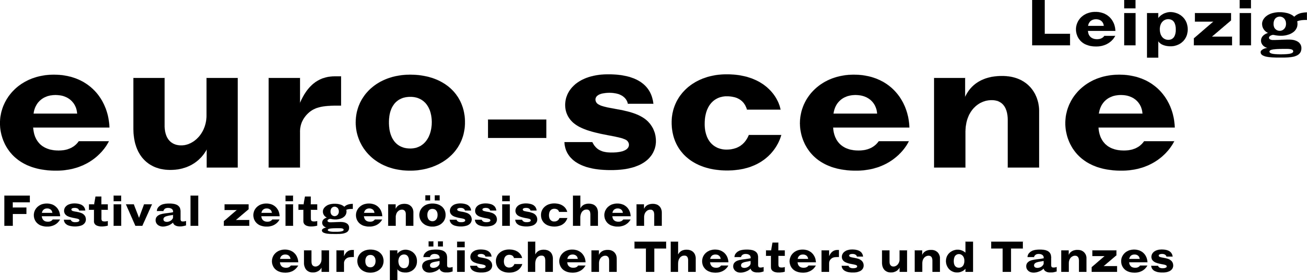
PRESS RELEASE – 11.11.2019

Anne-Hélène Kotoujansky from Strasbourg wins the competition “Das beste deutsche Tanzsolo” (“Best German dance solo”) 2019

Last night the theatre and dance festival euro-scene Leipzig ended with a guest performance by the Ballet Preljocaj from Aix-en-Provence. They presented three dance pieces by Angelin Preljocaj, one of France’s leading choreographers, at the sold-out Schauspielhaus, which met with enthusiastic applause and standing ovations.

The festival’s final night was followed by the final round of the competition “Das beste deutsche Tanzsolo” (“Best German dance solo”), which took place for the 14th time on the by now legendary round table. Anne-Hélène Kotoujansky from Strasbourg won the first prize for her solo “siebenundzwanzig – was ich mit dem Tanzen bis jetzt gelernt habe” (“twenty-seven – what I have learned from dancing so far”). The Frenchwoman completed her dance training at the conservatory in her hometown and at the Folkwang Universität der Künste, Essen.

The second prize was awarded by the 5-person jury to Shao-Yang Hsieh for his solo “j(us”). Born in Taiwan, the dancer currently studies contemporary stage dance in Linz. The third prize went to Elisabeth Kindler-Abali from Berlin for her solo “Quotenfrau” (“Token woman”), who graduated from the Palucca Hochschule für Tanz Dresden.

The audience award received Alina Belyagina from Munich for her solo “Pure.Image”. The prize includes a free stay of several days during the next euro-scene Leipzig. Further sponsors of the prizes are Konsum Leipzig eG, LONG HORN Lipsk Dry Gin, Leipzig, and the IntercityHotel Leipzig.

The Jury was comprised of Katja Erfurth, dancer, choreographer and board of Villa Wigman für TANZ e. V., Dresden / Prof. Dr. Claudia Jeschke, dance scholar, Munich and New York / Hermann Heisig, choreographer and dancer, Berlin / Martin Künanz, head of communication, Dresdner Musikfestspiele / Christian Watty, expert consultant at internationale tanzmesse nrw, Dusseldorf.

euro-scene Leipzig organises the competition “Das beste deutsche Tanzsolo” since 1997 according to a concept by the well-known Flemish choreographer Alain Platel from Ghent. Anyone was able to apply, regardless of age, training, style and nationality. In an internal pre-selection the festival director Ann-Elisabeth Wolff and René Reinhardt, artistic director of the competition, chose 20 dancers, who danced their 5-minute soli during the festival. The competition was once again a crowd-puller and sold out on all three nights.

Ann-Elisabeth Wolff
Festival Director

Information and contact: euro-scene Leipzig, Gottschedstraße 16, 04109 Leipzig,
tel. +49-(0)341-980 02 84 / info@euro-scene.de / www.euro-scene.de

