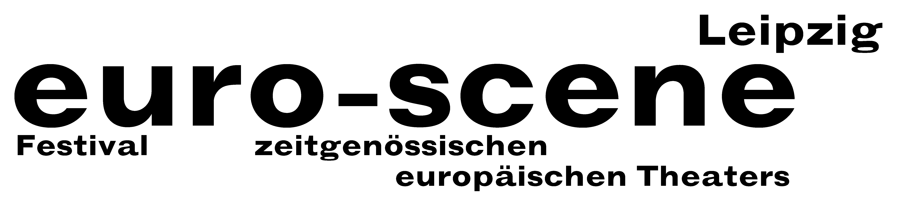

PRESS RELEASE (28.10.2007)

26 out of 178
Preselection for the competition "Das beste deutsche Tanzsolo" ("Best German Dance Solo!) is completed

Since this afternoon the participants for this year's competition "Das beste deutsche Tanzsolo“ ("Best German Dance Solo") have been fixed. 178 applicants from 22 countries faced up to the internal preselection at the Villa during the past two weekends. The festival director of the euro-scene Leipzig, Ann-Elisabeth Wolff, and the artistic director of the competition, René Reinhardt, have finally chosen 26 participants for the public rounds in November.

"It was a marathon. We saw about 40 hours of soli, talked to the dancers and discussed what we had seen“, said Ann-Elisabeth Wolff at the end of the preliminary rounds. "A wonderful band width of dance approaches, inspirations and energy, but also unexpected and very intimate things“ as René Reinhardt said.

The competition "Das beste deutsche Tanzsolo“, based on a conception by Alain Platel, Ghent, will be held for the 8th time within the festival euro-scene Leipzig (6–11 November). Anyone could apply, irrespective of age, training, style and nationality. With their soli of 5 minutes length the participants will face up to the audience and the jury consisting of 5 members on a round table of 7 m diameter from 9–11 November. They will finally decide which 11 dancers will come into the final round on 11 November. The first three winners will be awarded prize moneys between EUR 3,500.00 and EUR 1,500.00 by BMW plant Leipzig and euro-scene Leipzig.

The members of the jury are: Irina Pauls, choreographer, Leipzig / Rolf Dennemann, artistic director of the Festival off limits, Dortmund / Günther Jeschonnek, Fonds Darstellende Künste (Funds of Performing Arts), Berlin / Torben Kessler, actor, Schauspiel Leipzig / Klemens Wannenmacher, Kulturberater (cultural advisor), Rotterdam.

Ann-Elisabeth Wolff / Nadine Brockmann
Leipzig, 28.10.2007

Press contact: euro-scene Leipzig, Gottschedstrasse 16,-04109 Leipzig, phone +49 (0)341-212 67 66
presse@euro-scene.de // www.euro-scene.de

