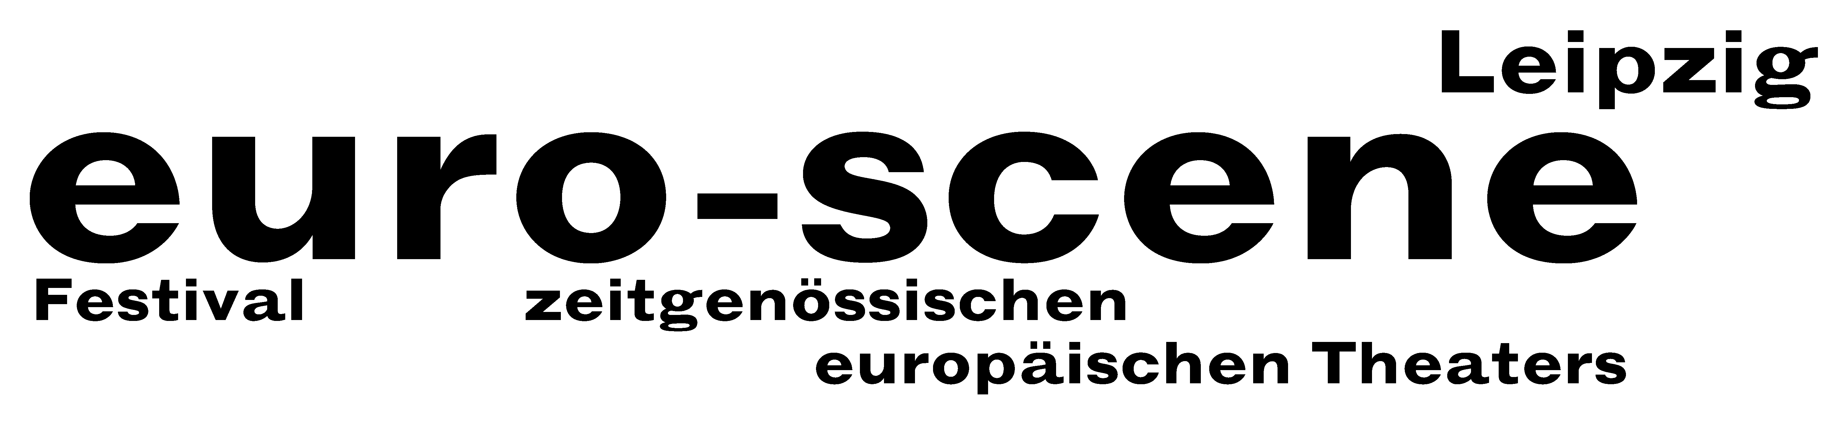

Press Release (12.11.2007)

Jianan Qu wins the competition "Das beste deutsche Tanzsolo" (“Best German Dance Solo”) 2007

In the final evening of the euro-scene Leipzig last night the competition "Das beste deutsche Tanzsolo“ (“Best German Dance Solo”) 2007 was brought to a close. The first prize of the jury consisting of 5 members went to Jianan Qu from Linz. With his solo "White Chrysanthemum“, he showed how the constantly required flexibility restrains modern human beings in their diversity and individuality.

The second prize and the prize of the audience went to the Italian Claudio Stellato, and the third prize went to Kyung Hee Woo from Korea.

The first three winners were awarded prize moneys between 3,500 EUR and 1,500 EUR, sponsored by the BMW Werk Leipzig and the euro-scene Leipzig. The prize of the audience includes a free stay at the next euro-scene Leipzig, sponsored by Hotel Holiday Inn Garden Court, Leipzig.

The competition "Das beste deutsche Tanzsolo“, based on a conception by Alain Platel, Ghent, took place for the 8th time within the festival euro-scene Leipzig. It was a big crowd puller; all three public rounds had already been sold out in advance.

Anyone could apply; irrespective of age, training, style and nationality. All in all 178 applications were received from 22 countries. In an internal preselection the festival director of the euro-scene Leipzig, Ann-Elisabeth Wolff, and the artistic director of the competition, René Reinhardt, chose 26 participants. They presented their solos of 5 minutes length on a round table of 7 m diameter.

The members of the jury were: Irina Pauls, choreographer, Leipzig / Rolf Dennemann, artistic director of the Festival off limits, Dortmund / Günther Jeschonnek, Fonds Darstellende Künste (Funds of Performing Arts), Berlin / Torben Kessler, actor, Schauspiel Leipzig / Klemens Wannenmacher, cultural advisor, Rotterdam.

The competition "Das beste deutsche Tanzsolo“ is held biennially and is scheduled to take place next time within the euro-scene Leipzig 2009.

Ann-Elisabeth Wolff // Nadine Brockmann
Leipzig, 12.11.2007

Press contact: euro-scene Leipzig, Gottschedstrasse 16, 04109 Leipzig, phone +49-(0)341-212 67 66
info@euro-scene.de // www.euro-scene.de

NOTE: Excerpts from the prize winning solos can be seen as video as from Tuesday (13.11.) under www.euro-scene.de/wettbewerb

