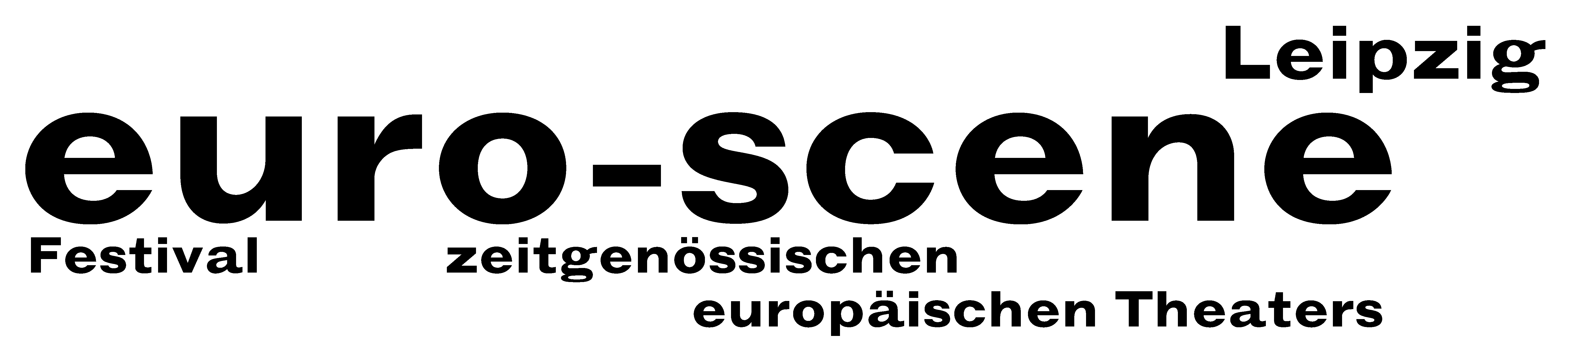

PRESS RELEASE (23.09.2009)

The secret of darkness

Theatre festival euro-scene Leipzig brings the "Eclipse of the sun" on Leipzig's stages

The euro-scene Leipzig will take place from 03 to 08 November 2009 for the 19th time. Under the motto "Sonnenfinsternis” (“Eclipse of the sun”), the festival of contemporary European theatre will show 13 guest plays from 10 countries in 25 performances and 10 theatre venues. The "Eclipse of the sun" serves as an allegory for an unusual situation, for danger and fear, the secret of darkness, but likewise for the hope of a new light. The festival is under the patronage by Burkhard Jung, Lord Mayor of the city of Leipzig.

"There is a before and an after and the moment at which the moon passes in front of the sun has always held a strong fascination for people. The experience of everyday life through to banality is what it always takes to make this short instant of a solar eclipse seem like an exceptional event”, says festival director Ann-Elisabeth Wolff. After the collapse of the social foundations 20 years ago, people today seesaw between uncertainty and hope, disappointment and waiting for more enlightening times – the clouded sun reflects this situation like a concave mirror finding its playfully blithe pendant in the glittering bright light of the stage projectors.

The Cullberg Ballet from Stockholm, one of Europe's most important dance companies, will be opening the festival with "Point of eclipse", a captivating dance play by the Swedish choreographer Johan Inger. Among the other festival highlights are the guest plays by the Muziektheater Transparant, Antwerp, assisted by the a cappella choir Collegium Vocale, Ghent, with the play "Ruhe" (“Quiet”) by Josse De Pauw, and "Hamletas" ("Hamlet") by William Shakespeare in a production by the Lithuanian director Oskaras Koršunovas from Vilnius. Julien Cottereau, long standing soloist at the Cirque du soleil, will be received as a guest from Paris with his extremely touching solo for young and old. At the close of the festival Nicole Mossoux & Patrick Bonté, Brussels, will be showing their dance play "Nuit sur le monde" ("Night across the world"). Among the eight German premieres are plays from Belgrade, Luxemburg and Belarus.

This year's Carte blanche for a guest play went to Sigrid Gareis, artistic director of the Tanzquartier Wien, who invited the Austrian choreographers Philipp Gehmacher and Milli Bitterli. The popular competition "Das beste deutsche Tanzsolo" (“Best German Dance Solo”), based on a conception by Alain Platel, Ghent, will be held in line with the festival for the 9th time.

The euro-scene Leipzig 2009 will be financed from funds of the city of Leipzig and the Free State of Saxony. Main partner for the 6th time already is the BMW Plant Leipzig. Cultural partner is the MDR Figaro, the media partners are the ZDFtheaterkanal, the city magazine kreuzer and nachtkritik.de. The festival is also supported by numerous embassies and cultural institutions.

Since its foundation in 1991, the euro-scene Leipzig has brought experimental theatre, innovative dance and performative art from throughout Europe to Leipzig every year in November. It is among the most important contemporary festivals of its kind in Europe.

Ann-Elisabeth Wolff
Leipzig, 23.09.2009

Contact:
euro-scene Leipzig, Gottschedstraße 16, 04109 Leipzig, tel. +49-(0)341-980 02 84
info@euro-scene.de // www.euro-scene.de

