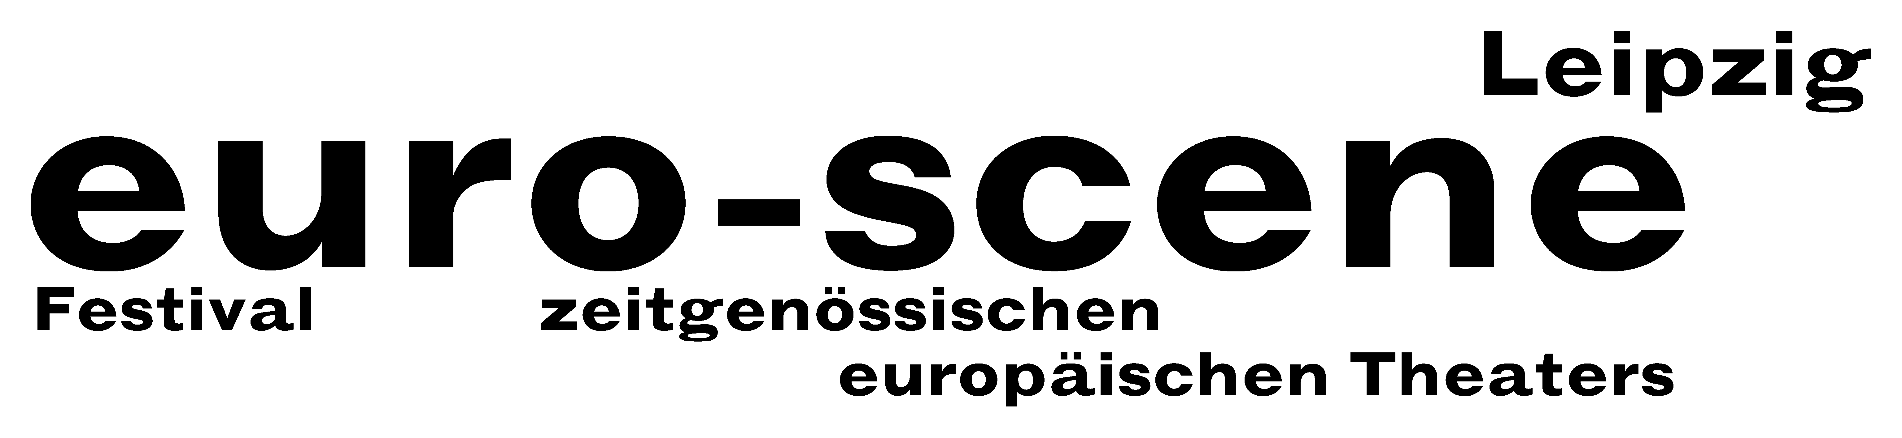

PRESS RELEASE – 10.07.2012

Exploding like a volcano

Theatre festival euro-scene Leipzig shows "Herbstzeitlose" ("Autumn crocus")
on the stages of the city

The euro-scene Leipzig will take place for the 22nd time from 6 to 11 November 2012. The festival of contemporary European theatre will show 12 guest plays from 9 countries in 23 presentations and 8 venues, among them 6 German premières. The festival enjoys the patronage of Burkhard Jung, lord mayor of the city of Leipzig.
The motto of the festival this year is "Herbstzeitlose" (“Autumn crocus"). The guest plays demonstrate the strong, individual scripting of major directors and choreographers from all over Europe. Romeo Castellucci, Cesena, will open the euro-scene Leipzig this year with "Sul concetto di volto nel figlio di Dio" ("On the concept of the face, regarding the son of God") and Sociètas Raffaello Sanzio. Oskaras Koršunovas from Vilnius and his Theatre OKT will show the play "Miranda“ based on Shakespeare's "The tempest". And finally Anne Teresa de Keersmaeker and her company ROSAS from Brussels can be seen in Leipzig with her dance piece "En atendant" as festival closure.

The German première of a theatre play by Jeton Neziraj with the company Qendra Multimedia from Pristina, Kosovo and a children's theatre piece from the company Theater Moment by Zoran Petrovič from Maribor, Slovenia, European Capital of Culture 2012, can be seen within the Spotlight on Eastern Europe. Moreover, there will be the witty women's choir Chór kobiet by Marta Górnicka from Warsaw and Familie Flöz from Berlin with its magical mask theatre piece "Infinita".

Ann-Elisabeth Wolff

Info and contact: euro-scene Leipzig, Gottschedstrasse 16, 04109 Leipzig,
Phone (0341) 980 02 84 / info@euro-scene.de / www.euro-scene.de

