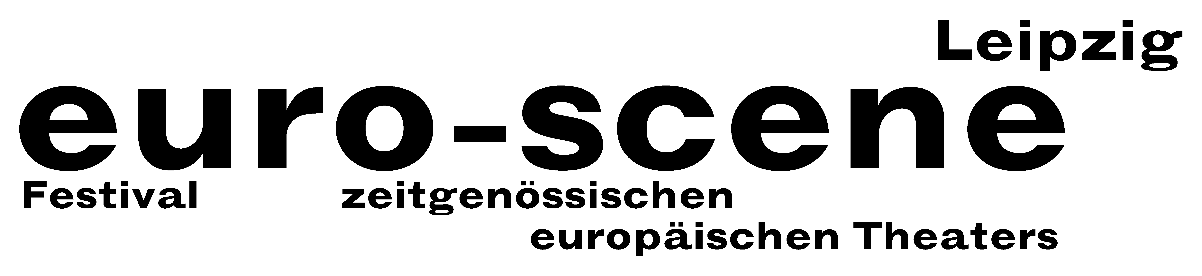
PRESS RELEASE – 26.09.2012

Exploding like a volcano

Theatre festival euro-scene Leipzig shows "Herbstzeitlose" ("Autumn crocus")
on the stages of the city

The euro-scene Leipzig will take place for the 22nd time from 6 to 11 November 2012. The festival of contemporary European theatre will show 12 guest plays from 9 countries in 23 presentations and 8 venues. The spectrum includes dance and spoken theatre, musical stage forms, performances and a play for children. Among them are 7 German premières. The euro-scene Leipzig holds a firm place in the European festival landscape. The festival enjoys the patronage of Burkhard Jung, lord mayor of the city of Leipzig.
The motto of the festival this year is "Herbstzeitlose" (“Autumn crocus"). This term coalesces with a secretive species of plant that is similar to the crocus and blossoms in late autumn, after every other plant has already lost its bloom. Their leaves sprout invisibly under the ground and shoot out unexpectedly months later. The autumn crocus is poisonous and yet also has a healing property that is used in medicine. "The developments in Europe have an almost eerie character due to their unpredictability and human behaviour sometimes explodes unexpectedly like a volcano", to quote festival director Ann-Elisabeth Wolff. As a metaphor, the term "autumn crocus" creates references to themes between life and death, the unexpected and liminal experiences.

The guest plays demonstrate the strong, individual scripting of major directors and choreographers from all over Europe. Romeo Castellucci from the northern Italian Cesena has been one of the most important and radical directors in Europe for years. He will open the euro-scene Leipzig this year with his much-discussed piece "Sul concetto di volto nel figlio di Dio" ("On the concept of the face, regarding the son of God") and Socìetas Raffaello Sanzio. Oskaras Koršunovas from Vilnius and his Theatre OKT will show the play "Miranda“ based on Shakespeare's "The tempest" in a fascinating modern version. And finally, after ten years, Anne Teresa De Keersmaeker, one of the most important European choreographers, and her company ROSAS from Brussels can be seen again in Leipzig with her dance piece "En Atendant" as festival closure.

The carte blanche – the selection of a guest performance – is provided to a renowned artist each year. This time, the "white card" is in the hands of Romeo Castellucci, who has decided upon two performances of the young Italian Silvia Costa, from Treviso. The German première of a theatre play by Jeton Neziraj with the company Qendra Multimedia from Pristina, Kosovo and a children's theatre piece from the company Moment by Zoran Petrovič from Maribor, Slovenia, European Capital of Culture 2012, can be seen within the Spotlight on Eastern Europe. Moreover, there will be the witty women's choir Chór kobiet by Marta Górnicka from Warsaw.

Two guest performances from Germany round out the festival programme: Rainer Behr, a long-time dancer for Pina Bausch in Wuppertal, presents his thrilling dance piece – fitting this year's festival motto – “Herbstzeitlose” (“Autumn crocus”) with Tanztheater des Theaters Bielefeld. And last, but certainly not least, Familie Flöz from Berlin finally comes to Leipzig for the first time with its magical mask theatre piece "Infinita".

The euro-scene Leipzig is financed from funds of the city of Leipzig and the Free State of Saxony. Main partner is the BMW Plant Leipzig for the last time after eleven years. Partners are the Best Western Hotel Leipzig City Center, Messedruck Leipzig, Café-Restaurant Telegraph, the International Theatre Institute (ITI), Berlin, and the incorporated association Richard-Wagner-Verband Leipzig. The festival is also supported by numerous embassies and cultural institutions. Cultural and media partners are the MDR Figaro, ARTE and info tv Leipzig.

Ann-Elisabeth Wolff
Festival Director

Info and contact: euro-scene Leipzig, Gottschedstrasse 16, 04109 Leipzig,
Phone: (0341) 980 02 84 / info@euro-scene.de / www.euro-scene.de

