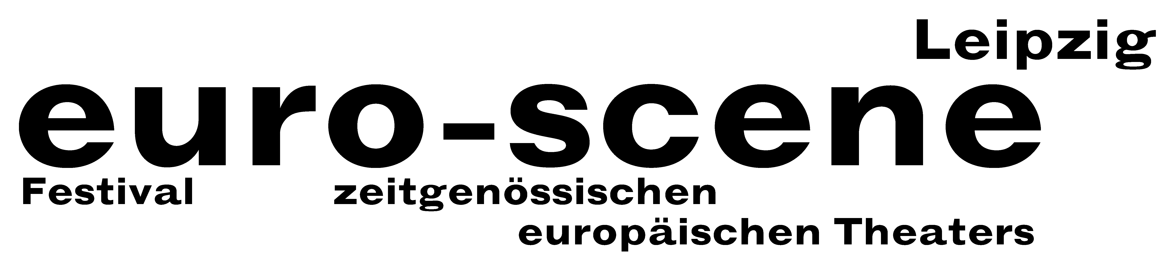

PRESS RELEASE audience award 12.11.2012

Familie Flöz from Berlin won the audience award of the euro-scene Leipzig 2012

This year an audience award for the "Most favourite play 2012" was bestowed for the first time. This price was announced on Sunday night just after the end of the festival: The winner was the renowned mask theatre Familie Flöz from Berlin with its play "Infinita". The award includes a fresh invitation for the company to the euro-scene Leipzig again with another production in one of the following years. Familie Flöz, headed by Hajo Schüler and Michael Vogel, is a theatre without words and combines elements of movement and body theatre – but its biggest secret lies in the phenomenal effect of the masks. It is planned to have another audience favourite award bestowed next year.

Ann-Elisabeth Wolff
Leipzig, 12. November 2012

Contact:
euro-scene Leipzig, Gottschedstrasse 16, 04109 Leipzig, Phone: +49-(0)341-980 02 84
presse@euro-scene.de // www.euro-scene.de

PLEASE NOTE: Images of all guest performances, of the festival director and the logo of the festival are available under www.euro-scene.de/presse.

