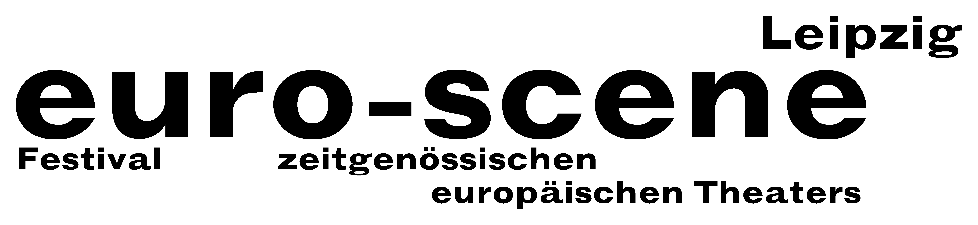

PRESS RELEASE – 25.09.2013 (Short version)

Milk becomes black

Festival euro-scene Leipzig shows theatre and dance from all over Europe

The euro-scene Leipzig will take place for the 23rd time from 05-10 November 2013. The festival of contemporary European theatre and dance will show 12 evenings of guest performances from
11 countries in 24 presentations and 8 venues. The festival enjoys the patronage of Burkhard Jung, lord mayor of the city of Leipzig.

This year, the festival's motto is "Schwarze Milch" ("Black milk"). This metaphor comes from the play of the same name by Latvian director Alvis Hermanis from Riga, which belongs to the festival guest performances this year. A focus of the festival is dedicated to the ballet "Le sacre du printemps" ("The rite of spring") by Igor Stravinsky, the most important dance piece of the 20th century. It had its world première in 1913 in Paris exactly 100 years ago. For this year's festival opening, euro-scene Leipzig will present work from three of the most innovative choreographers today: David Wampach, Montpellier, Tero Saarinen, Helsinki and Georges Momboye, Paris, added by a dance piece by Christine Gaigg, Vienna, and several films.

Other festival highlights are the music theatre "Ars vivendi" by CapriConnection & Schola Cantorum Basiliensis, directed by Anna-Sophie Mahler, and the dance piece “La curva” (“The curve”) by
Israel Galván, Sevilla, as final night. The popular competition "Das beste deutsche Tanzsolo" ("Best German dance solo") will be held for the 11th time.

Ann-Elisabeth Wolff
Festival Director

Information and contact: euro-scene Leipzig, Gottschedstraße 16, 04109 Leipzig,
Phone 0341-980 02 84 / info@euro-scene.de / www.euro-scene.de

