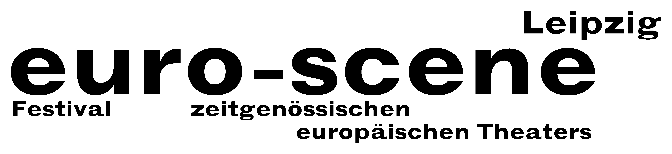

PRESS RELEASE – 25.09.2013

Milk becomes black

Festival euro-scene Leipzig shows theatre and dance from all over Europe

The euro-scene Leipzig will take place for the 23rd time from 05-10 November 2013. The festival of contemporary European theatre and dance will show 12 evenings of guest performances from
11 countries in 24 presentations and 8 venues. The spectrum includes dance and spoken theatre, performances, musical stage forms and a play for children. The festival enjoys the patronage of Burkhard Jung, lord mayor of the city of Leipzig. The programme selection lies in the hands of festival director Ann-Elisabeth Wolff.

This year, the festival's motto is "Schwarze Milch" ("Black milk"). This metaphor comes from the play of the same name by Latvian director Alvis Hermanis from Riga, which will be one of the festival guest performances this year. It deals with the loss of rural identity and the dangers of globalisation. "But the motto also functions as a synonym for collapse and decay, beginning and ending, for the changing of perspective over the course of our lives", says festival director Ann-Elisabeth Wolff.

A focus of the festival is dedicated to the ballet "Le sacre du printemps" ("The rite of spring") by Igor Strawinsky, the most important dance piece of the 20th century. Its world première in 1913 in Paris caused a scandal exactly 100 years ago. For this year's festival opening, euro-scene Leipzig will present work from three of the most innovative choreographers today: David Wampach, Montpellier, Tero Saarinen, Helsinki and Georges Momboye, Paris. In addition, a dance piece by Christine Gaigg, Vienna, will be presented. It combines choreographic elements from Vaslav Nijinsky, the choreographer of the première, with the artistic activities of Pussy Riot in Moscow 2012, thus bringing the work into the present.

Eastern Europe continues to be represented by two pieces of choreography from Prague by
Andrea Miltnerová and Compagnie Nanohach as well as the performance "Forecasting" by
Barbara Matijević & Giuseppe Chico from Zagreb / Bari. An unusual contribution comes from Switzerland: CapriConnection & Schola Cantorum Basiliensis will present the music theatre piece "Ars vivendi", directed by Anna-Sophie Mahler, who made a name for herself as the assistant of
Christoph Marthaler in Bayreuth. A magical children's play, "Il giardino di Gaia" ("Gaia's Garden"), will also be presented by Teatro Pan, Lugano. Finally, Israel Galván, Sevilla, one of the best flamenco dancers of our time, will close the festival with a guest performance of the dance piece
“La curva” (“The curve”).

The euro-scene Leipzig has formed a close partnership with Schauspiel Leipzig under its new artistic director Enrico Lübbe. This will result in the presentation of a co-production with the choreographer
Constanza Macras, Berlin. The piece “Rechnitz (Der Würgeengel)” ("Rechnitz (The exterminating angel)") by Elfriede Jelinek and directed by Enrico Lübbe will have its première during euro-scene Leipzig. The piece deals with the massacre in Rechnitz / Austria in 1945 and is to be understood as a parallel to the festival motto black milk. The poem "Todesfuge" ("Death fugue", 1944/45) by the German-Romanian author Paul Celan and its verse "Black milk at dawn" that has always been controversially discussed as "poetry of the Holocaust" also provides associations with the motto.

The popular competition "Das beste deutsche Tanzsolo" ("Best German dance solo"), in the conception by the renowned Flemish choreographer Alain Platel, Ghent, will be held for the 11th time.

The euro-scene Leipzig is financed from funds of the city of Leipzig and the Free State of Saxony. Partners are InterCityHotel Leipzig, Verbundnetz Gas AG, Leipzig, and cultural institutions as well as foundations. Cultural and media partners are MDR Figaro, ARTE, info tv Leipzig and der Freitag.

Ann-Elisabeth Wolff
Festival Director

Information and contact: euro-scene Leipzig, Gottschedstraße 16, 04109 Leipzig,
Phone 0341-980 02 84 / info@euro-scene.de / www.euro-scene.de

