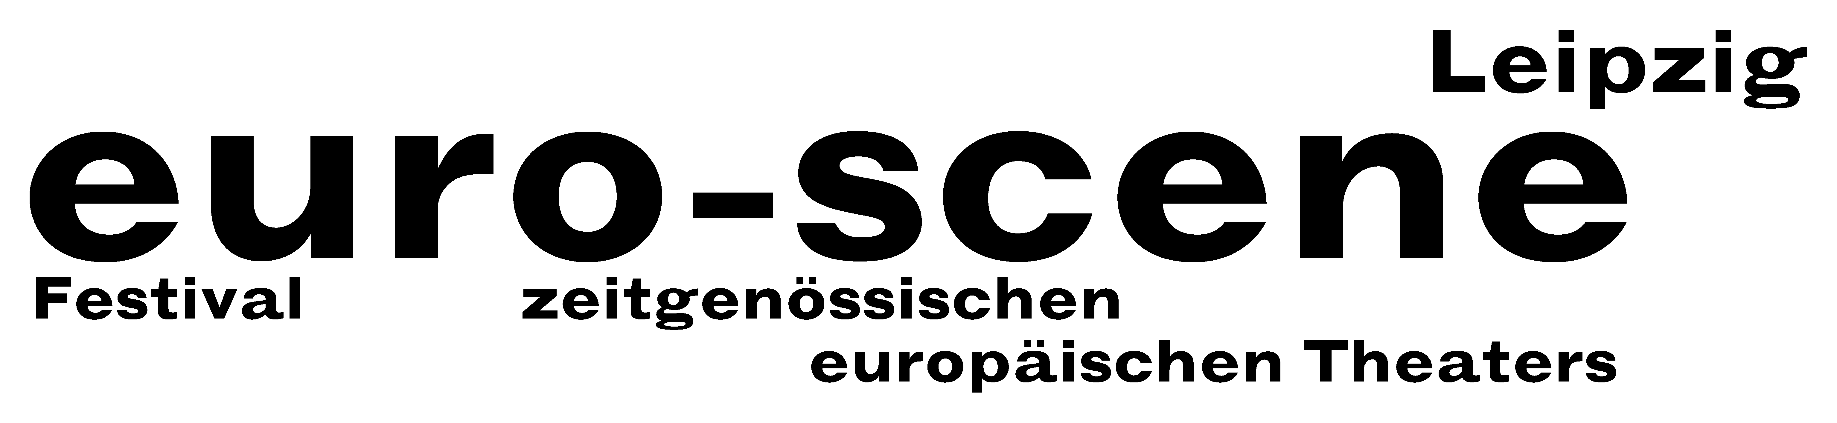
PRESS RELEASE – 05.11.2013

“Schwarze Milch” (“Black milk”) with 148 artists from all over Europe
as of today on Leipzig’s stages

euro-scene Leipzig will open tonight at the Schauspielhaus. The festival of contemporary European theatre will show three very different choreographies of the ballet “Le sacre du printemps” (“The rite of spring”) by Igor Stravinsky, being the most important dance piece of the 20th century. To be seen are the versions by David Wampach, Montpellier (as duet), Tero Saarinen, Helsinki (as solo) and Georges Momboye, Paris (with 12 dancers).

euro-scene Leipzig will take place from 05 – 10 November 2013 for the 23rd time and presents
12 evenings of guest performances from 11 countries in 24 presentations and 8 venues. The spectrum includes dance and spoken theatre, performances, musical stage forms and a play for children. This year, the festival's motto is “Schwarze Milch” (“Black milk”). This metaphor is based on the theatre play of the same name by Latvian director Alvis Hermanis from Riga, which will be one of the festival guest performances this year. It deals with the loss of rural identity and the dangers of globalisation. But the motto also functions as a synonym for collapse and decay, beginning and ending, for the changing of perspective over the course of our lives.

Since its founding in 1991, euro-scene Leipzig has become firmly established in the European festival landscape. The festival enjoys the patronage of Burkhard Jung, lord mayor of the city of Leipzig. The programme selection lies in the hands of festival director Ann-Elisabeth Wolff. This year a total of 148 artists and technicians from various European countries will come to Leipzig during the festival week.

The diverse guest performances demonstrate the strong, individual scripting of major directors and choreographers from all over Europe. Next to the opening night, the dance piece “DeSacre!” by Christine Gaigg, Vienna, also focuses on “Le sacre du printemps”. It combines elements of the choreographic original by Vaslav Nijinsky (1913) with the action of Pussy Riot in Moscow 2012, thus bringing the work into the present. An unusual contribution comes from Switzerland: CapriConnection & Schola Cantorum Basiliensis will present the music theatre piece “Ars vivendi” by
Anna-Sophie Mahler, who made a name for herself as the assistant of Christoph Marthaler and Christoph Schlingensief.

Furthermore, there will be the magical children's play “Il giardino di Gaia” (“Gaia's Garden”) with the Teatro Pan, Lugano. And finally, Israel Galván, Sevilla, one of the best flamenco dancers of our time, will close the festival with a guest performance of the dance piece “La curva” (“The curve”).

Together with the Schauspiel Leipzig, a dance piece by Constanza Macras, Berlin, will be premiered. And “Rechnitz (Der Würgeengel)” (“Rechnitz (The exterminating angel)”) by Elfriede Jelinek, staged by Enrico Lübbe, will have its premiere within euro-scene Leipzig. The piece deals with the massacre in Rechnitz, Austria, in 1945 and is to be understood as a parallel to the festival motto “Schwarze Milch” (“Black milk”).

The popular competition "Das beste deutsche Tanzsolo" ("Best German dance solo"), in the conception by the renowned Flemish choreographer Alain Platel, Ghent, will be held for the 11th time.

euro-scene Leipzig is financed by the city of Leipzig and the Free State of Saxony. Partners are the InterCityHotel Leipzig, Verbundnetz Gas AG, Leipzig, as well as cultural institutions and foundations. Cultural and media partners are the MDR Figaro, ARTE, info tv Leipzig and der Freitag.

Ann-Elisabeth Wolff
Festival Director

Information and contact: euro-scene Leipzig, Gottschedstraße 16, 04109 Leipzig,
Phone 0341-980 02 84 / info@euro-scene.de / www.euro-scene.de

