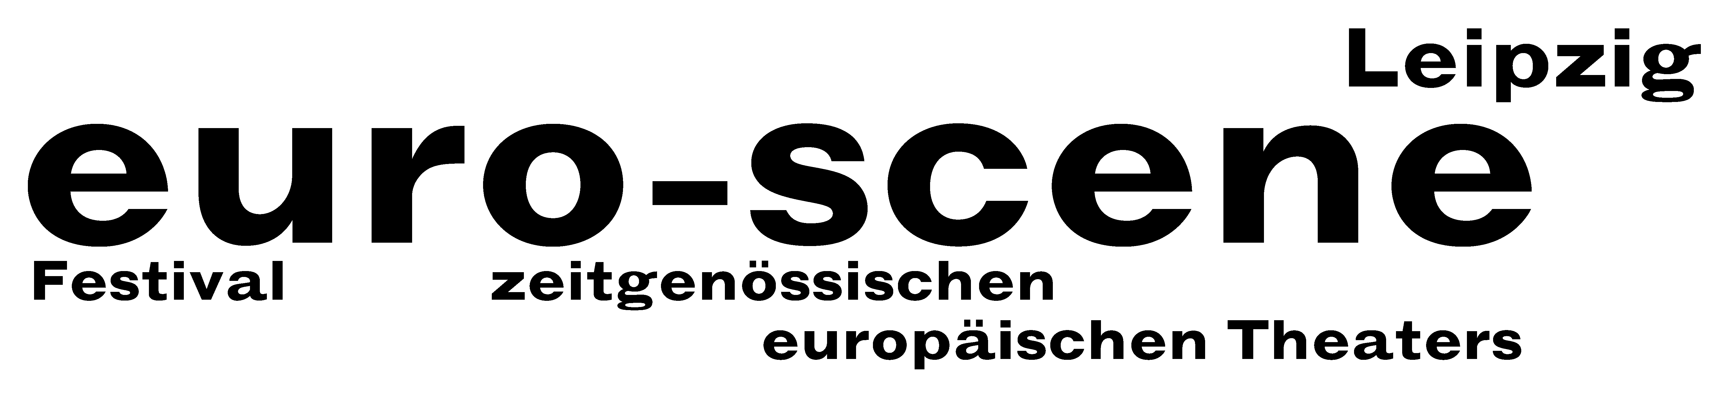

PRESS RELEASE – 11.11.2013

Justyna Kalbarczyk wins the competition “Das beste deutsche Tanzsolo” (“Best German dance solo”) 2013

The competition "Das beste deutsche Tanzsolo" ("Best German dance solo”) 2013 was decided during the final night of euro-scene Leipzig last evening. The jury consisting of 5 members awarded the first prize to Justyna Kalbarczyk from Berlin, born in Wrocław, who also won the audience award. With her solo “Bim bam bum”, based on music by Xavier Cugat, she found the right balance between art and entertainment.

The second prize went to Raphael Hillebrand from Berlin, born in Hongkong, and the third prize to the Polish Irina Demina from Hamburg.

The first three winners were awarded prize moneys between EUR 2,000.00 and EUR 500.00, with the support of the Fonds Darstellende Künste, Berlin, and Getränke Staude, Leipzig. The audience award includes a stay free at the next euro-scene Leipzig, sponsored by the InterCityHotel Leipzig.

The popular competition "Das beste deutsche Tanzsolo" ("Best German dance solo"), in the conception by the renowned Flemish choreographer Alan Platel, Ghent, was held at the wardrobe foyer of the Schauspielhaus. It was a big viewer magnet and all three evenings were sold out.

Anyone could apply independent of age, training, style and nationality. In total 82 applications were received from several countries. In an internal pre-selection the festival director of euro-scene Leipzig, Ann-Elisabeth Wolff, and the artistic director of the competition, René Reinhardt, chose 20 participants. They presented their solos of 5 minutes length on a round table of 7 m diameter.

The members of the jury were Esther Holland-Merten, dramatic adviser Schauspiel Leipzig, Montserrat León, head of Choreografisches Zentrum, Leipzig, Dr. Ina Lipp, medical consultant in general and nutritional medicine, Leipzig, Leipzig, Christian Syrotek, director InterCityHotel Leipzig, and Arnd Wesemann, editor tanz, Berlin.

The competition “Das beste deutsche Tanzsolo” (“Best German dance solo”) is held biennially and is planned to take place next time within the euro-scene Leipzig 2015.

Ann-Elisabeth Wolff
Leipzig, 11.11.2013

Press contact: euro-scene Leipzig, Gottschedstrasse 16, 04109 Leipzig,
phone +49-(0)341-980 02 84 // info@euro-scene.de // www.euro-scene.de

