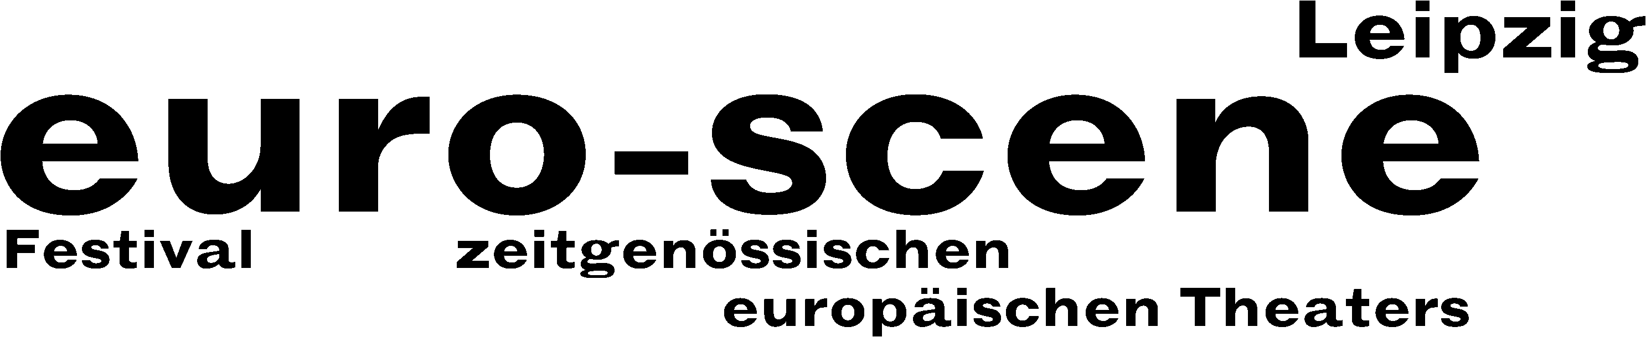

PRESS RELEASE – 24.09.2014 (short version)

In transit

euro-scene Leipzig festival shows theatre and dance from throughout Europe

This year, euro-scene Leipzig will take place from 04. – 09. November 2014 for the 24th time. The festival of contemporary European theatre and dance will show 12 guest plays from 8 countries in 23 presentations and 8 venues. The festival enjoys the patronage of Burkhard Jung, lord mayor of the city of Leipzig.

This time, the festival's motto is “Transit”. It is a metaphor for travelling through, restlessness, situations of upheaval in societies as well as the transition between life and death. The famous Flemish choreographer Alain Platel will open the euro-scene Leipzig with the dance piece “tauberbach”, a coproduction of his company les ballets C de la B, Ghent, and the Münchner Kammerspiele. The Ballet national de Marseille will present two very different choreographies by Olivier Dubois as well as “Orphée et Eurydice” by Frédéric Flamand based on the same name opera by Christoph Willibald Gluck.

The aesthetic variety of euro-scene Leipzig is broadly diversified: Eastern Europe is represented by the Puppet theatre Plovdiv and the Albanian dance theatre, fresh and bold performances come from Sweden and Switzerland. And finally Familie Flöz from Berlin will present their mask theatre piece “Hotel Paradiso”.

Ann-Elisabeth Wolff
Festival Director

Information and contact: euro-scene Leipzig, Gottschedstraße 16, 04109 Leipzig,
Phone +49-(0)341-980 02 84 / info@euro-scene.de / www.euro-scene.de

