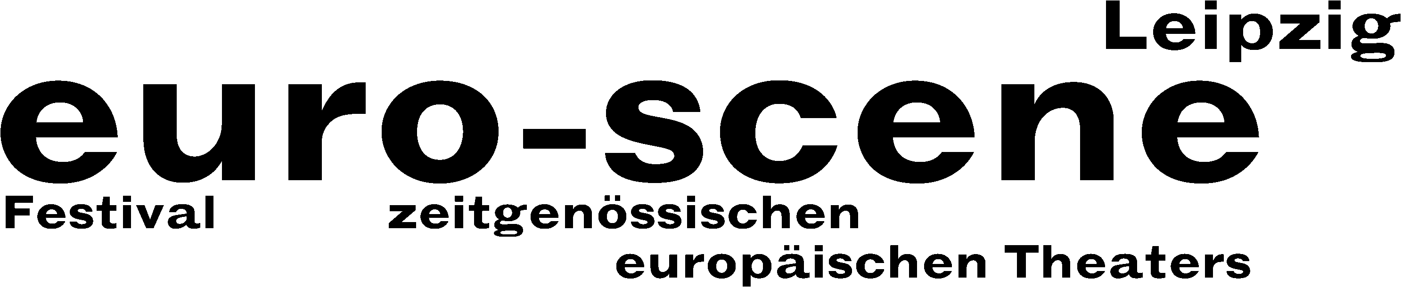

PRESS RELEASE – 24.09.2014

In transit

euro-scene Leipzig festival shows theatre and dance from throughout Europe

This year, euro-scene Leipzig will take place from 04. – 09. November 2014 for the 24th time. The festival of contemporary European theatre and dance will show 12 guest plays from 8 countries in 23 presentations and 8 venues, among them 5 German premières. The spectrum includes dance and spoken theatre, performances, musical stage forms and a play for children. The festival enjoys the patronage of Burkhard Jung, lord mayor of the city of Leipzig. The programme selection lies in the hands of festival director Ann-Elisabeth Wolff.

This time, the festival's motto is “Transit”. This metaphor implies the possibility of making one's own decisions in both directions, its freedom, but also its burden. “The motto also stands for travelling through, restlessness and inner labyrinths. Furthermore, situations of upheaval in countries and societies as well as the transition between life and death play a role”, says festival director Ann-Elisabeth Wolff. And finally, other “transit rooms”, namely those between theatre and dance, visual art and music, have become a tradition of euro-scene Leipzig in the meantime.

Alain Platel, one of the most important choreographers and directors of our time, has already been a guest in Leipzig several times. Now he will open the festival with the dance piece “tauberbach”, a coproduction of his company les ballets C de la B, Ghent, and the Münchner Kammerspiele. It is about the poorest in society, living at the margin of civilisation, who nonetheless uphold their human dignity. A key component here is the music by Johann Sebastian Bach.

Dance will also be represented by the Ballet national de Marseille showing two very different handwritings: The both fascinating and yet disturbing “Élégie” by Olivier Dubois and the opulent dance opera “Orphée et Eurydice” by Frédéric Flamand. It was created based on the opera “Orpheus and Eurydice” by Christoph Willibald Gluck whose 300th birthday also provided the occasion for the festival`s final night.

The focus on Eastern Europe lies on the Puppet theatre Plovdiv and its theatre play “Vgrajdane” (“Immured”) this time, which Veselka Kuncheva has staged intriguingly based on an ancient Bulgarian legend, the Albanian dance theatre, Tirana, with two dance pieces by Gjergj Prevazi, and the Aerites dance company, Athens, with a choreography by Patricia Apergi.

The aesthetic variety of euro-scene Leipzig is again broadly diversified: Familie Flöz from Berlin was the audience's darling in 2012 and will show its mask theatre piece “Hotel Paradiso” this time. Fresh and bold performances will be shown by the Swiss Martin Schick and the Swedish Björn Säfsten. And finally, Berndt Stübner and Werner Stiefel from Leipzig take up the tradition of children’s theatre with “Der Fischer und seine Frau” (“The fisherman and his wife”).

For the second time will euro-scene Leipzig be the partner of a world premiere at the Schauspiel Leipzig within the “Artists in Residence” series: Anna Natt from Berlin was selected with her performance “Der Dybbuk“ (“The Dybbuk“). In a reflection of the festival motto, the Schauspiel Leipzig will, furthermore, show the “Wolokolamsker Chaussee I-V” by Heiner Müller, staged by Philipp Preuss.

euro-scene Leipzig is financed by the city of Leipzig and the Culture Foundation of the Free State of Saxony as well as by numerous foundations, cultural institutions and partners. Cultural and media partners are: MDR Figaro, ARTE, info tv Leipzig and der Freitag.

Ann-Elisabeth Wolff
Festival Director

Information and contact: euro-scene Leipzig, Gottschedstraße 16, 04109 Leipzig,
Phone +49-(0)341-980 02 84 / info@euro-scene.de / www.euro-scene.de

