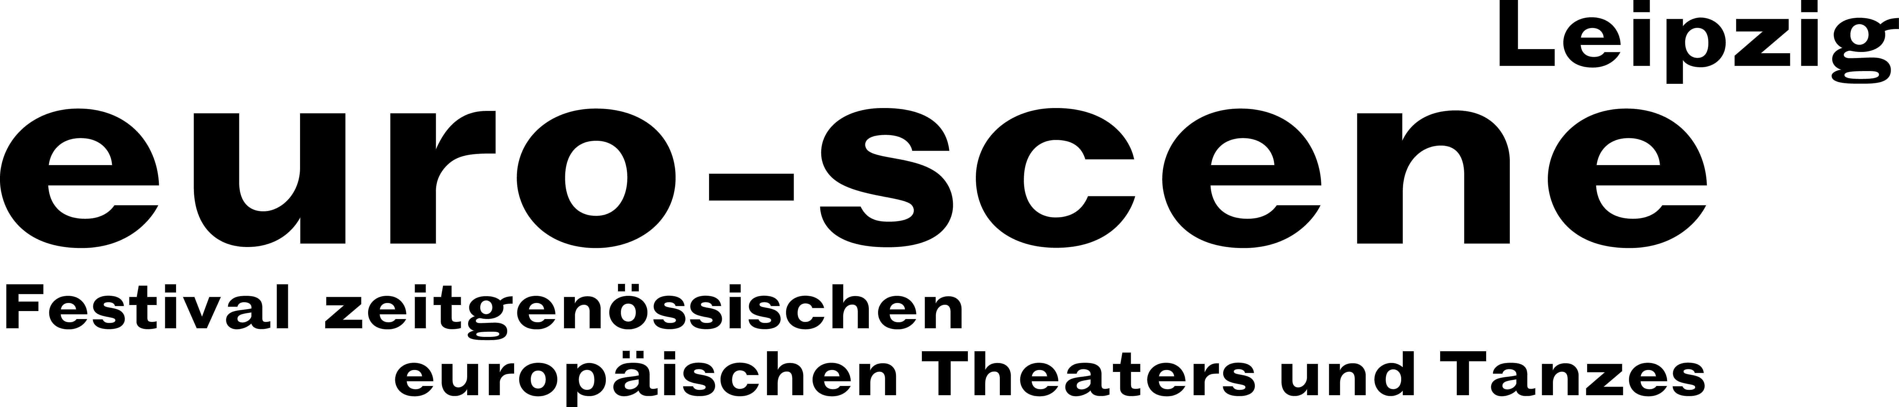
PRESS RELEASE – 23.09.2015

Exhilarating theatre arts from Europe in Leipzig

euro-scene Leipzig celebrates its 25th anniversary

euro-scene Leipzig will be held for the 25th time from 3 – 8 November 2015. The festival of contemporary European theatre and dance will show 15 guest plays from 11 countries in
27 presentations and 10 venues, among them 6 German premières and one world première. The spectrum includes dance and spoken theatre, performances, musical stage forms and a play for children. The festival enjoys the patronage of Burkhard Jung, Mayor of Leipzig. The programme selection lies in the hands of festival director Ann-Elisabeth Wolff.

The festival is a child of the political turning point in 1989 and was held for the first time in 1991 following the opening of Europe. It is now one of the cultural highlights of the city of Leipzig and has a fixed place in the European festival landscape. This year's euro-scene Leipzig will look back on this and celebrate, without forgetting the political and social tensions. At the same time, it will look forward to the future – and all of this will be expressed in this year's programming.

This year, the focus will be pieces that have been celebrated throughout the European theatre and dance landscape over the years: Anne Teresa De Keersmaeker, Brussels, and her company Rosas marked a new era in contemporary dance with their dance piece “Rosas danst Rosas” (1983). The piece was invited to Leipzig in 1992 for the second edition of the festival and it will now be seen once again, for the last time, as the festival opener.

Two solos will now finally be presented in Leipzig: The hilarious “The letter” by Paolo Nani from Denmark which has already been seen in over 30 countries and “Kefar Nahum” by Nicole Mossoux & Patrick Bonté, Brussels, a piece of fascinating and poetic object theatre. Philippe Saire, an outstanding Swiss choreographer, will present a guest performance of his original dance piece “Black out”.

There will be a reunion with artists who have influenced the style of Europe’s theatre and dance and are especially linked with the festival: Alain Platel from Belgium, Romeo Castellucci from Italy and Josef Nadj from France. With Bela Pintér, Budapest, one of the most important directors in Eastern Europe is coming to Leipzig. In addition, as a special event, a guest of the 1st festival in 1991 will be welcomed: the Polish director Leszek Mądzik with his company Scena Plastyczna KUL, Lublin, will present his piece “Bruzda” (“The furrow”) in the Peterskirche.

Yet there are also new discoveries: The Dutch choreographer Jan Martens has been the audiences' favourite at nearly every festival in Europe, Marie-Caroline Hominal will lure a single audience member at a time to a secret location with a performance, and the company La corde à vent from France will present a magic children's' piece with a lot of music and poetry.

A special treat is the video kaleidoscope “Transforming Acts” by Penelepe Wehrli & Detlev Schneider from Berlin, which present twelve of the most well-known choreographers and directors of the last 25 years through archival materials and interviews. Last but not least: The competition “Das beste deutsche Tanzsolo” (“Best German dance solo”) and its round table have now achieved cult status – inspired by a concept from the well-known Flemish choreographer Alain Platel, it will be held for the 12th time this year.

euro-scene Leipzig is financed by the city of Leipzig and the Cultural Foundation of the Free State of Saxony as well as by numerous foundations, cultural institutions and partners. Cultural and media partners are: MDR Figaro, ARTE, info tv and der Freitag.

Ann-Elisabeth Wolff
Festival Director

Information and contact: Information and contact: euro-scene Leipzig, Gottschedstraße 16, 04109 Leipzig,
Phone +49-(0)341-980 02 84 / info@euro-scene.de / www.euro-scene.de

